# How to Set Up 4-20ma Output for Water Meter

1. Connect RS485 output 485A and 485B from the meter to computer via RS485-USB adapter; and connect VDC and GND to 12VDC.

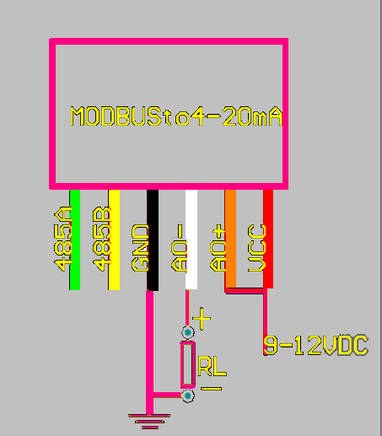

1. Download the 4-20mA & Modbus Software. <https://github.com/SpiremtSCM/-Software-Toolbox-/raw/master/4-20mA%20Modbus.exe>
2. Open the software. Select 9600 baud rate and open the corresponding COM port.

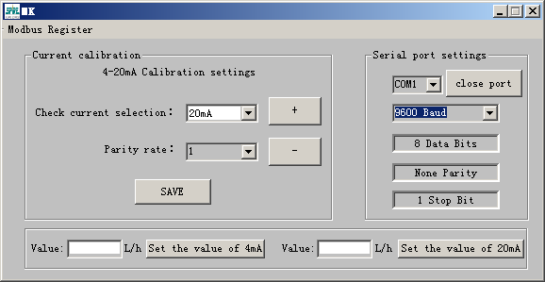

1. Enter the flow rate value (0 in most cases) for 4mA and click on “Set the value of 4mA”. Do the same for 20mA.